P.2 Literacy 2 Lesson Notes Term I - III

## THEME 1: HUMAN BODY AND HEALTH

Sub theme: External parts of the body and their uses

## Parts of the head

The head is the upper part of the body containing eyes, nose, ears, cheeks, chin, neck, tongue, teeth, mouth, eye brows, eyelids, eye lashes and the brain.

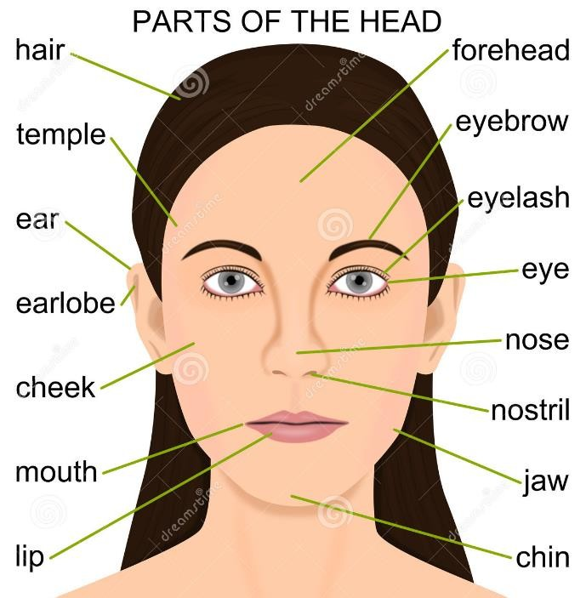

## Use of the parts of the head

1. **Eyes:** An eye is the part of the body used for seeing. Caring for eyes
   * Washing the eyes with clean water and soap.
   * Putting on sunglasses to protect them from direct sunlight, dust and foreign bodies.
   * Treat eyes when they are sick.
   * Eating food rich in vitamins.
   * Use clean piece of cloth to clean the eyes.
   * Provide enough light to read.

Problems to the eyes

* Foreign bodies.
* Too much sunshine.
* Diseases e.g trachoma, gonorrhea, night blindness.
* Smoke.

1. **Ears:** These are body organs used for hearing or listening. Care for ears
   * Washing them with clean water.
   * Avoid cleaning ears with sharp objects.
   * Removing the wax.

Problems to the ears

* + Too much noise affects the ears.
  + Deafness
  + Diseases
  + Foreign bodies
  + Infections

1. **Nose:** It is the part of the body used for smelling. Care for the nose
   * Cleaning the nose with clean water.
   * Cleaning with a clean handkerchief.
   * Do not put dangerous objects in the nose.

Problems to the nose

* + Foreign bodies
  + Diseases (nosal congestion)
  + Infections

1. **Teeth:** These are the organs found in the mouth and are white in colour.

Uses of the teeth

* + For chewing
  + For biting
  + For tearing
  + For grinding Caring for the teeth
  + Brushing teeth.
  + Removing food remains
  + Visiting the dentist every month.
  + Removing the sick tooth.
  + Avoid eating sugary things.

Problems to the teeth

* + Bleeding gum
  + Holes in the teeth
  + Diseases

## Parts of the chest

The chest is the middle part of the body with the following parts; arm, breasts, shoulder, back and armpit.

## Parts of the arm and hand

**Uses of parts of the arm**

## Hand

* + For holding
  + For defense
  + For picking
  + For clapping
  + For touching

## Finger nails

* + For beauty
  + For defense

Caring for parts of the arm

* + Washing with water.
  + Cutting fingernails short.
  + Do not touch hot things with naked hands.

Problems to the parts of the hand

* + Cuts
  + Fracture
  + Dislocation
  + Diseases

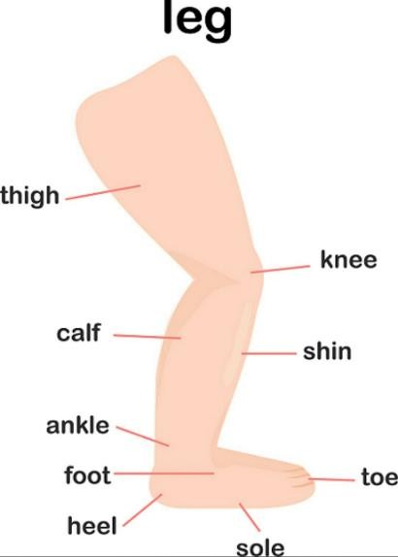 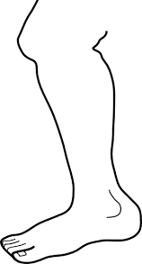

Uses of legs

* + For running
  + For kicking
  + For defence
  + For standing
  + For walking Caring for the legs
  + Washing the legs with water
  + Scrubbing the legs
  + Cutting toe nails
  + Putting on shoes Problems to the leg
  + Cuts
  + Dislocation
  + Fracture
  + Diseases

## Body organs and their senses

|  |  |
| --- | --- |
| **Body organ** | **Body senses** |
| eyes | seeing (sight) |
| ears | hearing |
| nose | smelling |
| tongue | tasting |
| skin | feeling |

Body exercises

* + Kicking
  + Running
  + Boxing
  + Press-ups
  + Jumping
  + Dancing
  + Skipping
  + Swimming
  + Sit-ups
  + Jogging Importance of body exercises
  + To be fit
  + To be healthy
  + To be strong

## Personal hygiene

This is the keeping of the body clean.

Ways of keeping the body clean

* + Bathing daily
  + Washing clothes
  + Brushing the teeth
  + Combing hair
  + Scrubbing the feet
  + Cutting finger nails
  + Ironing clothes

Things we use to clean the body

* + Sponge
  + Water
  + Soap
  + Comb
  + Towel
  + Tooth brush
  + Toothpaste
  + Basin
  + Razorblade
  + Nail cutter
  + Scissors

## Washing hands

What we use to wash hands

* + Clean water
  + Soap

When to wash hands

* + After visiting the latrine
  + Before eating food
  + After food

Why do we wash hands?

* + To remove dirt
  + To remove germs
  + To prevent diseases

## Brushing teeth

* + How to brush the teeth?

What to use when brushing

* + Toothbrush
  + Toothpaste
  + Water
  + Brushing stuck
  + Ash

When do we brush the teeth?

* + After meals
  + In the morning

Why do we brush the teeth?

* + To remove food remains
  + To prevent bad smell
  + To prevent tooth decay

## Bathing

What to use when bathing

* + Soap
  + Water
  + Sponge
  + Scrubbing brush

When to bathe

* + Bathe daily

Why do we bathe?

* + To remove sweat
  + To remove dirt
  + To remove bad smell
  + To prevent skin diseases

## Cleaning ears

When do we clean ears?

* + Regular

What to use when cleaning ears

* + Ear buds
  + Clean water
  + Cotton buds

Why do we clean the ears?

* + To be clean
  + To prevent diseases
  + To hear properly

## Cutting fingernails short

* + We cut fingernails short to remove hiding places of germs.
  + They cause damage to the skin.

Things used to cut fingernails short.

* + Razorblade
  + Nail cutter

## Washing clothes

* + How to wash clothes
  + Demonstration

Things used to wash clothes

* + Soap
  + Water
  + Basin

Why do we wash clothes?

* + To remove dirt.
  + To remove bad smell.
  + To be clean.

## Ironing clothes

Things we use to iron clothes

* + Flat iron
  + Iron box

Why do we iron clothes

* + To remove folds.
  + To look smart.
  + To remove dampness.
  + To kill vectors.

## Cleaning beddings

Examples of beddings

* + Bed sheets
  + Bed cover
  + Blankets
  + Pillow cases
  + Mattresses

How do we clean the beddings

* + Washing them
  + Ironing clothes
  + Putting them under the sun Why do we clean them?
  + To prevent diseases
  + To remove bad smell
  + To remove dirt when washing
  + To kill germs

## SANITATION

This is the keeping of the environment clean. Areas that need to be kept clean

* + House (well ventilated)
  + Latrine/toilet
  + Kitchen
  + Bathroom
  + Rack
  + Rubbish pit/dust bin/garbage bin/ trash bin
  + compound

## Question

How do we promote sanitation? (Activities done to promote sanitation)

## House

How to keep the house clean

* + Sweeping it
  + Mopping it
  + Removing cobwebs
  + Dusting windows and doors
  + Scrubbing the floor

Tools used to keep the house clean

* + Mop
  + Water
  + Rag
  + Soap
  + Broom
  + Vim
  + Squeezer

## Latrine/toilet

A latrine is a place where we ease ourselves from. Things found in the latrine/toilet

* + Tissue paper
  + Leaves
  + Water
  + Soap
  + Soft papers

Ways of keeping it clean

* + By sweeping
  + By smoking it
  + By removing cobwebs
  + By mopping

Tools used to keep the latrine clean

* + Vim
  + Broom
  + Water
  + Jik
  + Dry banana leaves/grass
  + Scrubbing brush (draw the diagrams) Why do we smoke the pit latrine?
  + To control vectors
  + To reduce bad smell Improper use of latrine
  + Urinating on top
  + Defecating on top
  + Writing on walls

Dangers of improper use of latrine

* + It creates a bad smell
  + It causes diseases

## Kitchen

A kitchen is a place where food is prepared from. Ways of keeping it clean

* + By mopping
  + By sweeping
  + By scrubbing
  + Removing cobwebs

Tools used to clean the kitchen

* + Mop
  + Water
  + Rag
  + Soil
  + Broom
  + Vim

Things used in the kitchen

* + Saucepans
  + Cooking stoves/stands
  + Electrical/gas cookers

Dangers of a dirty kitchen

* + It spreads diseases
  + It causes bad smell

Why we keep the kitchen clean?

* + To prevent bad smell
  + To prevent diseases
  + To prevent vectors

## Bathroom

A bathroom is a place where we bathe from. Things we use in the bathroom

* + Water
  + Sponge
  + Soap
  + Towel

Improper use of a bathroom

* + Defecating in it
  + Urinating in it
  + Writing on walls How can we keep it clean?
  + Scrubbing the bathroom
  + Removing cobwebs
  + Draining water
  + Sweeping

Materials used to clean the bathroom

* + Water
  + Jik
  + Soap
  + Vim
  + Broom
  + Scrubbing brush

## Rack

A rack is an object where we put utensils to dry Ways of caring for a plate stand

* + Washing it
  + Painting it to avoid rusting

## Rubbish/dustbin/garbage bin/trash bin

* + A rubbish pit is a hole where we put rubbish.
  + A dust bin is a container where we put rubbish.

Ways of managing rubbish

* + By picking
  + Using a dust bin

## COMPOUND

Dangers of a dirty compound

* + It causes bad smell
  + It causes diseases
  + It is a breeding place for vectors

How do we keep the compound clean?

* + Sweeping
  + Picking rubbish
  + Draining still water
  + Clearing the bush around our homes

Why do we keep the compound clean?

* + To prevent bad smell
  + To prevent diseases

Tools used to clean the compound

* + Broom
  + Dustbin
  + Rake
  + Wheelbarrow
  + Slasher Importance of sanitation
  + It prevents diseases
  + It controls vectors
  + It prevents bad smell
  + It controls accidents

Dangers of poor sanitation

* + It leads to accidents
  + It leads to diseases
  + It causes a bad smell
  + It attracts vectors

## Good health habits

* + Brushing teeth
  + Eating in time
  + Sweeping
  + Bathing
  + Sleeping in time
  + Washing hands
  + Washing clothes
  + Mopping
  + Burning rubbish
  + Eating a balanced diet
  + Doing body exercise
  + Taking children for immunisation

Common diseases

* + Flu - Cough
  + Measles - T.B
  + Malaria
  + Dysentery
  + Mumps
  + Chicken pox
  + Ring worms
  + Typhoid
  + Cholera
  + Diarrhoea

Causes of common diseases Diseases are caused by germs.

Germs are living organisms that cause diseases.

Spreading of germs

Germs are spread by vectors.

Vectors are living things that spread germs.

## Diseases with their vectors

|  |  |
| --- | --- |
| **Disease** | **Vector** |
| Malaria | Mosquito |
| Trachoma | Housefly |
| Dysentery | Housefly |
| Cholera | Housefly |
| Diarrhoea | Housefly |
| Sleeping sickness | Tsetse fly |
| Nagana | Tsetse fly |
| Cholera | Cockroach |
| Diarrhoea | Cockroach |
| Dysentery | Cockroach |
| Rabies | Mad dog |
| Typhus fever | Tick & flea |
| Anaemia | Bedbug |

How to prevent common diseases

* + Washing hands before eating
  + Covering food
  + Cooking food properly
  + Spraying
  + Avoid sharing clothes
  + Maintain personal hygiene
  + Sleeping under treated mosquito nets

## THEME 2: FOOD AND NUTRITION

**Food** is something good to eat or drink.

**Feeding** is the act of taking in food.

**Nutrition** is the act taking in food and how it is used in the body.

Common foods we eat

* + Fish
  + Honey
  + Milk
  + Beans
  + Yams
  + Cassava
  + Oranges
  + Meat
  + Vegetables
  + Carrots
  + Rice
  + Pineapple
  + Maize
  + Pumpkins
  + Sweet potato
  + Millet **Note:** Diagrams Sources of food
  + Plants
  + Animals
  + Garden
  + Market
  + Shop
  + Supermarket
  + Water bodies
  + Rain
  + Hotel

Places where we get food from

* Garden -Shops
* Restaurants - Lake
* Swamps
* Rivers
* Markets
* Supermarkets
* Hotels

Reasons why we eat food Looking at the 5Hs they are;

* To be healthy
* To kill hunger
* It is a habit
* For hospitality
* To be happy

Therefore, writing 5Hs in full it is;

* Healthy
* Happy
* Hunger
* Habit
* Hospitality

Importance of food in the body

* We eat food to grow well.
* We eat food to get energy.
* To repair worn out cells.
* To prevent diseases

## A balanced diet

This is a meal with food values in their correct amount. Classification of food

* Proteins
* Carbohydrates
* Vitamins
* Minerals
* Fats and oils
* Water
* Roughages

1. **Proteins** are body building foods (Grow foods) Examples of food rich in proteins
   * Meat
   * Milk
   * Eggs
   * Chicken
   * Fish
   * Beans
   * Soya beans
   * Groundnuts
   * Cow peas

Uses of proteins in our body

* + Helps in body growth.
  + Repair worn out cells.

### Its deficiency disease is kwashiorkor

1. **Carbohydrates** are energy giving foods. (Go foods) Sources of carbohydrates
   * Posho
   * Rice
   * Millet
   * Wheat
   * Bread
   * Irish potato
   * Sweet potato
   * Cassava
   * Honey
   * Banana
   * Sugarcane
   * Yams
   * Milk

Uses of carbohydrates in the body

* + They provide energy in the body.
  + They produce heat in the body.

### Its deficiency disease is marasmus

1. **Vitamins** are health giving foods or protective foods (Glow foods)

Sources of vitamins

**Note:** Vitamins are mostly got in; Vegetables e.g

* + Dodo
  + Nakati
  + Carrots
  + Cabbages
  + Tomato
  + Green pepper

Fruits

* + Guava
  + Apples
  + Oranges
  + Pineapple
  + Pawpaw
  + mangoes Examples of vitamins

VitaminA, Vitamin B1, Vitamin B12, Vitamin D, Vitamin E, Vitamin K

Vitamin C is got from fruits and vitamin D is obtained from the sun

Uses of vitamins in the body

* + They keep the body healthy.

Its deficiency diseases are;

* + scurvy from vitamin C
  + rickets from vitamin D and
  + night blindness from vitamin A

## Fats and oils

Sources of fats and oils Fats

* + Ghee
  + Milk
  + Blue band
  + Cow boy
  + Meat
  + Egg yolk Oils
  + Milk
  + Cooking oil
  + Sun flower
  + Groundnuts Uses of fats and oils
  + It provides energy to do work.
  + It produces heat in the body. Dangers of too much fat in the body
  + It brings obesity
  + It leads to body tiredness
  + It leads to heart failure

## Roughages

Sources of roughages

* + Cabbage
  + Dodo
  + Pumpkin leaves
  + Sukuma wik
  + Mangoes
  + Sweet potato
  + Cassava

Uses of roughages

* + They prevent constipation

## Mineral salts

Examples of minerals

* + Iodine
  + Calcium
  + Ion
  + Phosphorus Sources of minerals
  + Calcium
    - Salt
    - Milk
    - Fish
    - Beans
    - Eggshell
  + Iron
    - Liver
    - Egg yolk
    - Meat
    - Leafy vegetables
  + Iodine
    - Iodized salt
    - Sea weeds
    - Sea water

Uses of minerals

* + Calcium makes our bones strong.
  + Calcium makes teeth strong.
  + Iron helps in blood formation.

## Water

Importance of a balanced diet in the body

* It makes us strong (gives energy)
* It makes the body grow.
* It prevents us from diseases. Dangers of poor feeding
* It leads to diseases.
* It leads to death.
* It leads to body weakness.
* It leads to blindness.

## Malnutrition

This is a poor state of health due to poor feeding. Signs of malnutrition

* Loss of weight
* Body weakness
* Dullness
* Poor eye sight
* Change of hair
* Bleeding gum
* Dry pale skin
* Being restless
* Swollen neck

## Food preparation

This is the way food becomes ready for eating. Methods of food preparation

* By mingling
  + Posho
  + Millet
  + Bread
  + Matooke
  + Sweet potato
* By roasting
  + Meat
  + Chicken
  + Maize
  + Cassava
  + Banana
* By frying
  + Fish
  + Eggs
  + Chicken
  + Cassava e.t.c
* By baking
  + Bread
  + Cakes
  + Doughnuts
  + Chaps
  + Chapatti
* By boiling
  + Eggs
  + Milk
  + Meat
  + Water
  + Rice e.t.c
* By steaming
  + Matooke
  + Rice
  + Meat
  + Green vegetables e.t.c Why do we cook food?
* To kill germs
* To give it a taste
* To make it soft

## Food preservation

This is the keeping of food safe from for a long time.

Methods of food preservation

## Local methods

Smoking

* + Fish
  + Meat
    - Sun drying
  + Fish
  + Beans
  + Maize
  + Cassava Salting
  + Fish
  + Meat
  + Chicken e.t.c

## Modern methods

Freezing

* + Milk
  + Meat Canning/Tinning
  + Milk
  + Meat
  + Beans
  + Fish e.t.c

Reasons for preserving food

* + - For future use.
    - To prevent it from going bad.

Places where food is kept safe

* + - Granary
    - Store
    - Refrigerator Foods kept in a granary
    - Maize
    - Beans
    - Groundnuts
    - Dried cassava
    - Millet

## Food hygiene

This is the keeping of food clean Ways of food hygiene

* + - By covering it.
    - By putting it in a clean container.
    - By preparing it in a clean place.
    - By eating it with clean hands.
    - By serving it with clean hands.
    - By serving it from a clean place.

## Food contamination

This is the way food becomes dirty

Ways of food contamination

* + - Using dirty utensils.
    - Using dirty hands when eating.
    - Preparing it from dirty places.
    - Serving it from dirty places.
    - Leaving it open.
    - Using dirty hands when serving.

What makes food dirty?

* + - Rats
    - Houseflies
    - Cockroaches
    - Dirty hands
    - Dirty utensils Dangers of eating dirty food
    - It leads to diseases e.g cholera, typhoid, dysentery, diarrhoea.
    - It leads to death.

Good eating habits

* + - Washing hands before eating food.
    - Eating slowly.
    - Eating while sitting down.
    - Washing hands after eating food.
    - Praying before eating food.
    - Chewing food well.
    - Eating slowly.

Bad eating habits

* + - Eating while standing.
    - Eating while playing.
    - Talking while eating.
    - Eating food with dirty hands.
    - Eating food before praying.

## TERM TWO

**THEME: OUR ENVIRONMENT**

**Definition:** Environment are things around us.

## OR

Environment is man and his surroundings.

Components of the environment

These are things that make up the environment. They include;

* + - Plants
    - Animals
    - Hills
    - Water bodies
    - Air
    - Buildings
    - Valleys
    - Mountains
    - Soil
    - Rocks
    - Man

Groups of things in the environment There are two groups. These include;

1. Living things
2. Non – living things

Characteristics of living things

* + They respire
  + They reproduce
  + They grow
  + They feed
  + They move
  + They excrete
  + They respond to stimuli

## Examples of living things

* + Tress/plants
  + Housefly
  + Grasshoppers
  + Fish
  + Snakes
  + Man
  + Monkey
  + Worms
  + Lions
  + Snails
  + Lizards
  + Bees
  + Squirrels e.t.c Groups of living things

1. Plants
2. Animals Non- living things

These are things which do not have life. Characteristics of non-living things.

* + They do not respire.
  + They do not reproduce.
  + They do not grow.
  + They do not feed.
  + They do not move.
  + They do not excrete.
  + They do not respond to stimuli.
  + They do not have cells. They have particles.

Examples of Non- living things

* + Air
  + Soil
  + Stones
  + Water
  + Building
  + Duster, etc.

Activities that change /spoil the environment

* + Cutting down trees
  + Bush burning
  + Poor methods of farming
  + Brick making
  + Quarrying
  + Over fishing
  + Over grazing
  + Harvesting sand
  + Poaching
  + Fish poisoning

Ways of conserving the environment/protecting the environment

* + Mulching
  + Planting trees
  + Terracing
  + Avoid bush burning
  + Avoid over grazing
  + Proper disposal of rubbish
  + Use of proper methods of farming

## Animals in the environment

Groups of Animals

1. Domestic animals
2. Wild animals

Domestic animals are animals kept at home. Examples of domestic animals

* + Cow
  + Pigeon
  + Duck
  + Turkey
  + Goat
  + Chicken
  + Pig
  + Camel
  + Rabbit
  + Dog
  + Donkey
  + Cat

Importance of animals in the environment

* + Some animals provide us with meat.
  + Some animals provide us with milk.
  + Some animals provide us with feathers for decoration.
  + Some animals are used for transport.
  + Some animals are sold and we get money.
  + A dog can be used to guard our homes
  + They provide us with skins and hides.
  + Their droppings are used as manure.
  + Bees give honey.
  + Rabbits give us fur.
  + Sheep provide us with silk for making clothes.
  + Some animals are used for cultural purpose, like paying dowry.

Wild animals

These are animals that live in bushes or forests. Examples of wild animals

* + Lion
  + Snakes
  + Giraffe
  + Buffalo
  + Zebra
  + Baboons
  + Elephant
  + Wolf
  + Tiger
  + Leopard
  + Weaver birds
  + Flamingo Importance of wild animals
  + Some animals provide us with meat.
  + Some animals provide us with skin and hides.
  + We get ivory from elephants.

Dangers of animals

-

* + Some animals kill people.
  + Some animals spoil crops.

## Birds

Groups of birds

1. Domestic birds
2. Wild birds

Domestic birds (poultry)

These are birds kept at home. Examples of domestic birds

* + Turkey
  + Chicken
  + Ducks
  + Pigeons
  + Guinea fowl
  + Geese
  + Parrot Wild birds

These are birds which live in the bush. Examples of wild birds

* + Owl
  + Eagle
  + Weaver bird
  + Crested crane
  + Vulture
  + Wood pecker
  + Egret
  + Sunbird Importance of birds
  + Birds give us meat.
  + Birds give us eggs.
  + Birds provide us with feathers.
  + We get droppings from birds which is used as manure.
  + Some birds are sold and people get money.

Dangers of birds

* + Some birds spoil the crops.
  + Their droppings can pollute the environment.
  + Some birds eat domestic birds.

## Animal products

Animal Product (s)

Cow - milk, meat, horns, hooves, hides, cow dung, bones, blood.

Goat - milk, meat, skins, horns, hooves, dung, blood.

Sheep - milk, meat, wool, hooves, blood. Poultry - feathers, eggs, flesh, droppings. Pig - meat, bristles, lard, hooves.

Rabbits - meat, fur, droppings. Elephants - ivory, hides

Things got from hides and skins

* + Bags
  + Shoes
  + Belts
  + Carpets
  + Balls
  + Jackets
  + Drums
  + Sofa sets

**NB**: Teacher should draw the above diagrams. Products got from milk

* + Ghee
  + Cheese
  + Yoghurt
  + Butter
  + Ice cream

Products got from animals wastes

* + Manure
  + Biogas Animals and their legs Two legged animals

Examples

* + Man
  + Birds
  + Bats Four legged animals Examples
  + Cows
  + Monkey
  + Giraffe
  + Goats
  + Pig
  + Lion
  + Elephant
  + Dog
  + Zebra
  + Chameleon Animals without legs
  + Snake
  + Snails
  + Maggot
  + Worms
  + Fish
  + Cell worms
  + Slug

Animals with many legs (more than 4 legs)

* + Centipedes
  + Caterpillar
  + Millipedes
  + Scorpion
  + Housefly
  + Bee
  + Ticks
  + Grasshopper
  + Lice
  + Crabs

## Animal movements

Animal Movement

Man - walks/runs

Snake - glides Caterpillar - wrigglers Birds - flys

Fish - swims

crawls creeps Jumps hops runs/walks flys

|  |  |
| --- | --- |
| Baby | - |
| Snail | - |
| Frog | - |
| Grasshopper | - |
| Dog | - |
| Bat | - |
| Crocodile | - |
| Tortoise | - |
| Lizard | - |

crawls crawls crawls

.

Why animals move?

* + To look for food.
  + To look for protection.
  + To look for partners (mating)
  + To look for shelter.
  + To look for water.
  + To look for their young ones.
  + To produce youngones/lay eggs.
  + To look for materials.
  + To look for friends.

## Animals’ homes/habitats.

A home is a place where animals stay and live. A habitat is a home of a living thing.

## Animal homes

Animal homes

Cow - kraal/byre/cowshed

Goat - pen/goatshed

Pig - sty

Lion - den

Bird - nest

Dog - kennel Wild rabbit - Burrow Man - house Domestic rabbit- hutch

Snake - burrow/water/grass Earthworms - tunnel

Termites - anthills

Bees - hive

Spider - cob web

Parrot - cage

Horse - stable

Monkey - forest

Cat - basket

Sheep - pen/shed Cockroach - dark places Housefly - dirty places Chameleon - Trees **Animal weapons**

Animal Weapon

Chameleon - colour change

Cow - horns

Dog - teeth

Man - hands/teeth/legs/nails

Lion - teeth/claws

Elephant - trunk

Cat - claws

Snake - Fangs/poison (venom)

Bird - beak/claws/spur

Fish - fins

Bed bug/skunk - bad smell Frog - slippery body Porcupines/hedgehog- spins Tortoise and snail - shells Crocodile - teeth/tail

Caterpillar - prickly hair

Bee - sting

## How animals protect themselves?

Animal Protection Bee - stinging

Chameleon - changing colours

Millipedes - coiling Caterpillar - pricking Scorpion - stinging

Python - squeezing

Snail - hiding in the shell.

Cow - knocking/kicking

Bedbug - producing bad smell Dog - biting/scratching

Cat - biting/scratching

Snake - biting and spitting venom

Man - fighting/biting/kicking

**Animal Youngones Animal Youngones** Dog - puppy Turkey - poult Man - baby Fish - FRY Hen - chick Goose - gosling Birds - nesting Sheep - lamb Lion - cub Cockroach - nymph

Elephant - calf Housefly - maggot Cat - kitten Mosquito - wriggler Duck - duckling Frog - tadpole Crocodile - hatching Monkey - baby Pig - piglet Rat/mice - pups **Animal sounds**

Animal Sound

Rat/mice - squeaks

Pig - grunts

Man - talks

Bird - whistles/sings/chirps

Monkey - chatters

Horse - neighs

Elephant - trumpets

Dog - hisses

Snake - bleats Sheep/goat - bleats Lion/leopard - roars Cat - pulps

Bee - buzzes

Cow - moos

Baby - cries Why animals make sounds? For protection

When in danger

For communication When hungry/thirty When they are happy. When they are angry. When they want to mate.

## Animals and their food

Dog - bones

Cat - milk/rats

Baby - breast milk Cows goat, sheep - grass/peelings Man - bread

Rabbits - pellets/leaves

Turkey - insects/grains

Hyena/lion - flesh

Frog - insects Lizard/chameleon - insect Snakes - insects

Bats/birds - fruits/insects

## Animal meat

Pig - pork Sheep - mutton Cow - beef Chicken - chicken Goats - goats’ meat Fish - fish fillet

Calf - veal

# INSECTS

Characteristics of Insects

* + They have three main body parts.
  + They have six legs.
  + They have two compound eyes.
  + All insects have a pair of feelers.

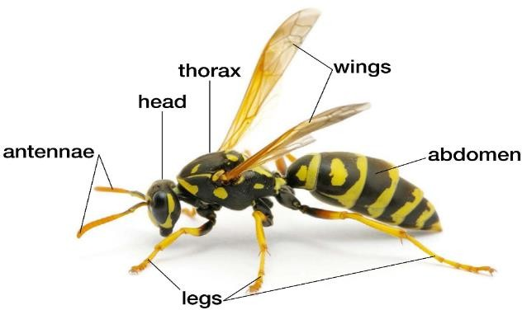Parts of an insect

Common insects

* Mosquito
* Praying mantis
* Tsetse fly
* Crickets
* Houseflies
* Termites
* Grasshopper
* Locusts
* Bees
* Wasps
* Moths
* Butterfly
* Ants
* Cockroaches

## Groups of insects

1. Harmful insects
2. Useful insects

Examples of harmful insects

* Bees
* Cockroaches
* Housefly
* Termites
* Wasp
* Tsetse fly
* Locusts

Dangers of harmful insects

* Some insects destroy crops.
* Some insects spread disease.
* Bees and wasps sting.
* Some insects bite.

Examples of useful insects

* Beetles
* Bees
* Grasshopper
* White ants
* Butterfly
* Moth

Uses of insects

* Some insects can be eaten.
* Some insects pollinate flowers.
* A bee gives us honey.

## CHANGES IN INSECTS (Lifecycles)

1. Complete life cycle
2. Incomplete life cycle

## Complete life cycle

This is the life cycle with four stages of development. Namely: Eggs, Larva, Pupa, Adults

Egg larva

Adult pupa

Examples of insects which undergo complete life cycle

* Butterfly
* Housefly
* Tsetse fly
* Black fly
* Bee
* Wasp
* Mosquito
* Moth

## Incomplete lifecycle

This is the lifecycle with three stages of development. Namely; Egg, Nymph, Adult.

Egg Nymph

Adult

Examples of insects with incomplete lifecycle

* Locusts
* Crickets
* Termites
* Grasshoppers
* Cockroach
* Playing mantis

## Lifecycle of butterfly

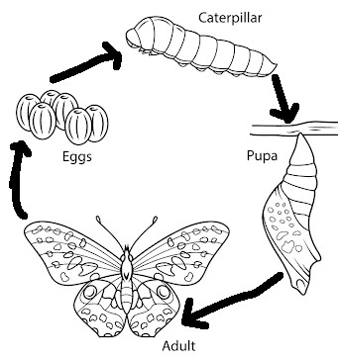

**Lifecycle of a housefly**

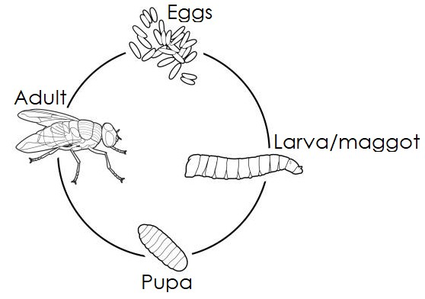

## Lifecycle of a cockroach

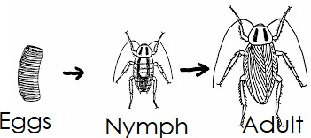

**Life cycle of a grasshopper**

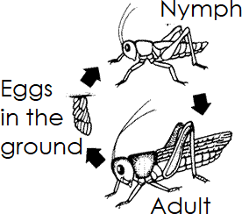

## PLANTS

A plant is a green living thing. Examples of common plants

* Banana plant
* Onion plant
* Mango plant
* Sugarcane plant
* Pineapple plant
* Cactus plant
* Pawpaw plant
* Sisal plant
* Cassava plant
* Sorghum plant
* Bean plant
* Ferns e.t.c

Places where plants grow

* On water e.g, water lily, suds, water hyacinth
* Dry places e.g, sisal, cactus.
* Swamps eg., cabbages, sugarcane, yams, rice
* Garden e.g, cassava, potatoes, banana
* Rocks e.g, Liverworts, lichens

Groups of plants

## Non flowering plants

These are plants which do not bear flowers.

Examples of non-flowering plants

* + Mosses
  + Liverworts
  + Pine
  + Cypress

## Flowering plants

These are plants which bear flowers. Examples of flowering plants

* + Banana plants
  + Maize plants
  + Cassava plants
  + Bean plants e.t.c

## Types of flowering plants

1. Dicotyledonous plants
2. Monocotyledonous plants

## Dicotyledonous plants

These are plants which produce seeds with two cotyledons.

*Examples of dicotyledonous plants*

|  |  |
| --- | --- |
| * Mango plant * Sim sim plant * Bean plant * Cow peas plant * Cotton plant | Soya bean plant   * Coffee plant * Avocado plant * Coconut plant * Jack fruit plant e.t.c |

## Monocotyledonous plants

These are plants which produce seeds with two cotyledons.

*Examples of monocotyledonous plants*

* Maize plant
* Rice plant
* Wheat plant
* Oats plant
* Barleyplant
* Sorghum plant
* Millet plant

## Parts of a plant

Main parts of a

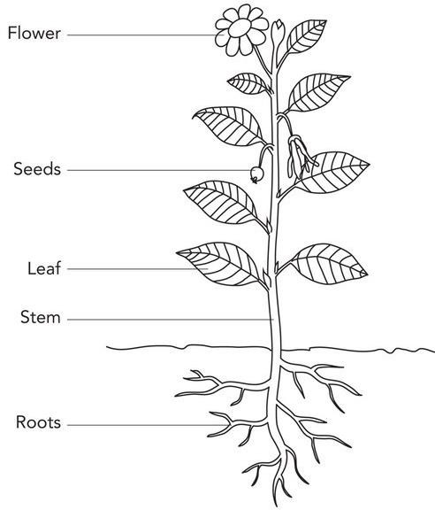

plant

1. Leaves
2. Stem
3. Roots

|  |  |
| --- | --- |
| **Part** | **Uses to the plant** |
| Roots | * Roots hold the plant firmly in the soil. * Roots absorb water and mineral salts from the soil. * Some roots act as food store for a plant. |
| Stems | * It holds the leaves, branches, flowers and fruits above the ground. * Stems transports water and mineral salts from the roots to the leaves. * Some stems store food for the plant. |
| Leaves | * They make food for the plant. * Leaves help plants to breathe through the stomata. * Some leaves store food for the plant. |

## Uses of parts of a plant to man

|  |  |
| --- | --- |
| Leaves | * Some leaves are used as food e.g. cabbages. * Leaves give us herbal medicine. * Some leaves are used to thatch houses. |
| Stems | * They give man timber. * They are used as herbal medicine. * They give us food e.g. sugarcane, irish potatoes, |

|  |  |  |
| --- | --- | --- |
|  | yams.  - They give us firewood and charcoal. |  |
| Roots | * Roots are eaten as food e.g cassava, sweet   potatoes   * Some roots give us herbal medicine. |

**Uses of flowers to people**

* + For decoration
  + Some flowers are used as herbal medicine
  + Some flowers are eaten

## Uses of plants to man

* Plants give us food.
* Some plants provide us with herbal medicine.
* Plants act as wind breakers.
* Plants give us charcoal and firewood.
* Plants provide building materials e.g poles, timber.
* Plants are a source of oxygen.
* Plants are a source of raw materials to industries.
* Some plants are habitats of some animals.

## Dangers of plants

* Some plants spoil our crops.
* Some plants smell bad.
* Some plants are poisonous to us.
* Some plants prick us i.e they pierce us.
* Some plants hide dangerous animals e.g cactus, spear grass, sisal, coach grass

## Ways of caring for crops

|  |  |
| --- | --- |
| Weeding | - This is the removal of unwanted plants from the  garden. |
| Weeds | - These are unwanted plants from the garden. |
| Pruning | - This is the cutting or removal of excess branches  from a plant. |
| Thinning | - Is the removal of excess plants from the garden. |

|  |  |
| --- | --- |
| Mulching | - Is the covering of the soil with dry plant materials  e.g leaves |
| Watering | - Is the applying of water to plants. |
| Spraying | - Is the applying of pesticides to plants. |
| Staking | - Giving support to a plant. |
| Harvesting | - Is the removal of ready crops from the garden. |
| gap filling | - Is the filling of spaces where crops did not grow |

**Garden tools and their uses**

|  |  |  |
| --- | --- | --- |
| Hoe |  | * For digging * For harvesting * For weeding |
| Panga |  | * For cutting small trees * For harvesting * For pruning |
| Rake |  | * For collecting rubbish * For collecting grass |
| Trowel |  | - For transplanting seedlings |
| Wheel barrow |  | * For carrying manure * For carrying harvested crops |
| Axe |  | - For cutting trees |

|  |  |  |  |
| --- | --- | --- | --- |
| Watering can |  | - For watering crops |  |

**Parts eaten on a plant**

|  |  |
| --- | --- |
| leaves | * Cabbage * Onions * Lettuce * Sukuma wiki * Nakati * Spinach * Pumpkin |
| Roots | * Carrot * Sweet potatoes * Cassava * Beet root * Yam |
| Stem | * Sugarcane * Yams * Irish potatoes |
| Flower | - Cauli flower |
| Fruit | * Mango * Apple * Tomato * Pawpaw * Orange |

# GERMINATION

Germination is the development of a seed into a seedling. A seedling is a young plant.

## Conditions necessary for germination

These are things that seeds need to grow into seedling.

* Water(moisture)
* Air (oxygen)
* Warmth

## Nursery bed

This is a place where seeds are first planted to grow into seedlings before being transplanted to the main garden.

## Importance of a nursery bed

* It helps a farmer to sort out good seedlings.
* It provided shade to the seedlings.

## Seed grown in a nursery bed

* Tomatoes
* Onions
* Red pepper
* Bitter tomatoes
* Egg plants
* Garlic
* Carrots
* Cabbage
* Green pepper
* Passion fruits
* Lettuce

## Structure of a nursery bed

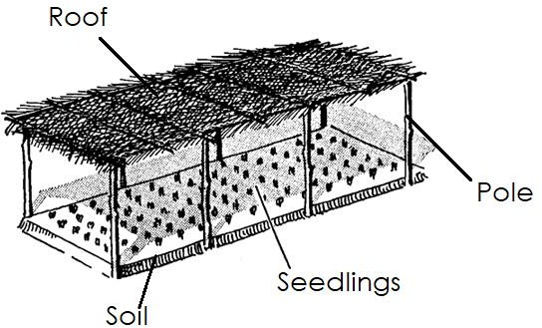

**Stages of plant growth**

Seed seedling plant

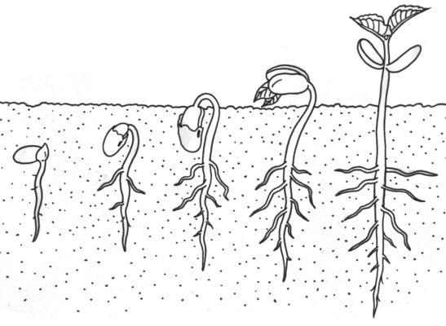

## Ways of caring for seedlings

* By watering them
* By spraying them
* Providing a shade for them

## Tools / equipments used in a nursery bed

1. Watering can - For watering
2. Trowel - For transplanting seedlings
3. Spray pump - For spraying **THEME 3: ACCIDENTS AND SAFETY Accident**

An accident is a sudden danger that causes harm or death.

## Common accidents at home and school

* Drowning
* Burns
* Bites
* Electric shock
* Stings
* Lightning strikes
* Cuts
* Nose bleeding
* Fractures
* Scalds
* Bruises
* Poisoning
* Falls

## Things that cause accidents (dangerous objects)

* Broken bottles
* Nails
* Thorns
* Razor blades
* Needles
* Gun
* Arrows
* Barbed wire
* Panga
* Cars
* Knives
* Poison
* Medicine
* Broken glasses
* Stones

## Causes of accidents at home and school

* Playing with sharp objects like knives, pins, panga e.t.c
* Playing dangerous games
* Climbing trees
* Playing near water bodies
* Leaving medicine at the reach of children
* Playing with or near fire
* Throwing stones
* Playing with naked electric wires
* Misunderstanding between neighbours
* Playing near or in bushes
* Over running
* Playing with hot things
* Un supervised swimming
* Playing in rain
* Walking bare footed

## Preventing accidents at home and school

* Do not play with sharp objects
* Do not play with dangerous animals and insect
* Do not climb trees and ladders
* So not play in the bush
* Do not play with electric wires
* Do not play near water bodies
* Do not leave medicine at the reach of children
* Slash bushes around our homes and schools
* Do not over run
* Do not play dangerous games
* Do not touch naked electric wires
* Do not walk bare footed
* Do not play with poison
* Do not play with broken glasses/bottles

## Common accidents on the road

* Bruises
* Drowning
* Fractures
* Cuts
* Bites
* Lightening strike
* Knocks

## Things that cause accidents on the road

* Broken bottles
* Broken wires
* Nails
* Stones
* Pot holes
* Vehicles

## Causes of road accidents

* Playing on the road
* Over loading
* Over speeding on the road
* Over taking
* Careless driving
* Driving when one is drunk
* Receiving phone calls when driving
* Not following road signs and traffic rules
* Walking bare footed
* Bad roads

## Ways of controlling accidents on the road

* Do not over load
* Do not play on the road
* Repair bad roads with pot holes
* Do not over speed
* Do not over run
* Do not play in the rain
* Follow road signs
* Do not drink and drive
* Do not over take
* Drive carefully
* Do not talk on phone when driving

## Effects of results/consequences/outcomes/dangers of accidents

* Death - Poverty
* Loss of jobs - Loss of property
* Lameness
* Pain and suffering - Family suffering

## FIRST AID

First aid is the first help given to a casualty before being taken to the hospital.

## Casualty

This is a person who has got an accident.

## First aider

Is a person who gives first aid.

## Qualities of a good first aider

* He should be quick
* He should be kind
* He should be gentle
* He should be knowledgeable
* He should have common sense
* He should be observant

## Reasons why we give first aid

* To save life
* To prevent further injuries
* To reduce pain
* To prevent quick recovery

## FIRST AID BOX

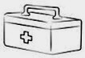This is a container where we keep things used to give first aid.

## Things found in the first aid box

* Razor blades
* Spirit
* Bandage
* Cotton wool
* Scissors
* Plaster
* Pain killers
* Iodine
* Soap
* Clean cloth
* Safety pin
* Gauze
* Liniment

## Places where first aid box are found

* Hospitals
* Homes
* Schools
* Banks
* Churches
* Aeroplane
* Vehicles
* Hotels

**NOTE:** An ambulance is a vehicle which takes the causality to the hospital.

First aid kits are things used to give first aid. These are things found in the first aid box or the equipment.

## Different first aid given to different accidents

|  |  |
| --- | --- |
| Accident | First aid |
| Fracture | - Apply splints |
| Nose bleeding | * Pinch the nose * Use a cold pad |
| Snake bite | * Tie above the bitten part * Give cold milk |
| Poison | - Give cold milk |
| Burns and scalds | - Pour cold water |
| Drowning | * Mouth to mouth breathe * Press the stomach |
| Cuts and wounds | - Clean wound with clean water |
| Electric shock | - Give cold milk |

**THEME 4: MEASUREMENTS**

## Time of the day

1. Morning time - 06:00am (midnight to 11:59am)
2. Mid day - at 12:00 noon
3. Afternoon - from 12:00noon – 5:59pm
4. Midnight - at 12:00am

## Measuring length and height

Things we measure height and length

* + Person
  + Trees
  + Buildings
  + Clothes
  + Desks
  + Blackboards
  + Books, etc.

Things used to measure length and height

* + Handspan
  + Armspan
  + Arm’s length
  + Foot/feet
  + Strides
  + Tape measure
  + Ruler

Length is measured in centimeters and metres.

**N.B:** Diagrams to be drawn Measuring weight (mass)

weigh is the heaviness or lightness of an object.

Weight is measured in kilograms/grams. Things we measure in kilograms and grams

* + Sugar
  + Rice
  + Beef/meat
  + Beans
  + Person
  + Sorghum
  + Millet
  + Flour
  + G. nuts
  + Powdered milk

Things/tools we use to measure weight

* + Weighing scales
  + Beam balance
  + See saw
  + A set of scales
  + Scale balance

**N.B**: Diagram to be drawn by the teacher

## Measuring liquid things (capacity)

Liquid things are measured in litres.

Things we measure in litres (Examples of liquid things)

* Water
* Oil
* Juice
* Milk
* Fuel
* Diesel
* Acid
* Liquid soap
* Soda
* Wine e.t.c

Things we use to measure liquids

* Tins
* Cups
* Jerrycans
* Measuring cylinder
* bottles
* Packets, etc.

## N.B: Diagram to be drawn by the teacher